

AGM and a talk by Guy Stephenson —
“The Kiplingcotes Derby”
Thursday 7th October 2010
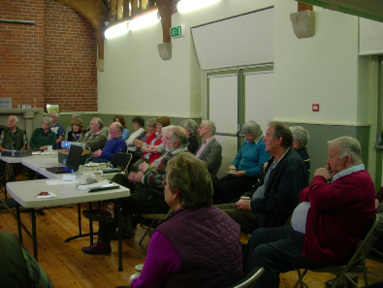
There was a good turn-out for the AGM, encouraged by the prospect of the talk by Guy Stephenson!
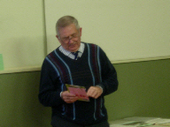
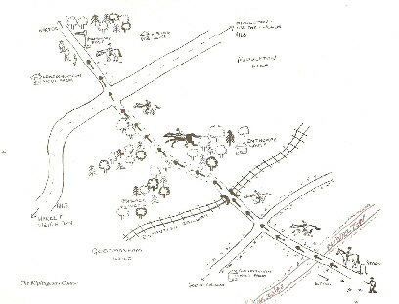
The Kiplingcotes Derby, first held in 1519, is the oldest horse race on the flat. The 4 ½-mile race is run on the most testing ground in East Yorkshire, near Market Weighton, on the third Thursday in March. The finishing post is near one of the Stephenson farms, Londesborough Wold, where most of the crowd congregate.
A clause in the race's 1669 endowment states that if it misses a year, it can never be run again.
Mr Stephenson said that the weather is a major factor, never more so than in 1947 when there were 10ft snow drifts on the course during the worst winter in living memory.
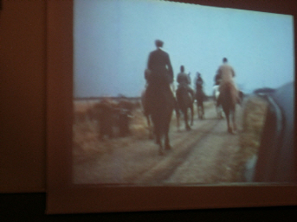
"My uncle Fred walked the course with a cart horse to ensure the race's continuity and a sole rider completed it in 2001 for the same reason when foot and mouth disease closed the countryside."
Mr Stephenson showed a DVD of some the cine films he had taken of the race in the 1950s and 1960s.
Fascinating !

